

**Modeling Data in Excel**

Julien Rahal

201203217

Section -7-

Thursday, December 8, 2011

Introduction

* **Motivation:**

Seizing the flexibility and importance of a spreadsheet as the one provided by Excel.

* **Objectives:**

1. Calculating the volume and the area of a cone for different values of its radius.
2. Modeling the results obtained in form of a graph.
3. Using MathType to write the cone equations.

* **Overview:**

In this report we are interested in a particular geometric shape: the cone. We aim to calculate the volume and area of a cone while being able to change some inputs such as the radius value. This objective can be attained using different methods including the use of a programming language, spreadsheets… But, in what follows we are using spreadsheets admitting that it requires less skills than programming.

Outline page

1. Introduction -2-
2. Background -3-
3. Modeling Process -4-
4. Tools -7-
5. Results -9-
6. Conclusion -11-
7. References -12-
8. Appendices -13-

Background

“A cone is a solid figure generated by a line, one end of which is fixed and the other end describes a closed curve in a plane. A circular cone is a solid figure whose base is a circle and whose lateral surface area (i.e. curved surface area) tapers uniformly to a point: which is called the vertex or apex. The axis of the cone is a straight line drawn from the vertex to the center of the base. A right circular cone is a cone whose base is a circle and whose axis is perpendicular to the base. Such a cone can also be described as solid formed by a right triangle rotated about one of its sides as an axis; it may, therefore, be called a cone of revolution. The figure below represents a right circular cone.”

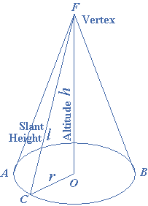

For simplicity, we are going to deal with right circular cones.

Modeling Process

**Cone Equations:**

The [volume](http://mathworld.wolfram.com/Volume.html) of a cone is:

**V = $\frac{1 }{3 }B.h$**

Where B is the base [area](http://mathworld.wolfram.com/Area.html) and h is the height. If the base is circular, then:

$$B=π.r^{2}$$

Where r is the radius of the base.

The volume equation becomes:

**V = $\frac{1 }{3 }π.r^{2}.h$**

The surface area S, not including the base, is given by the following formula:

$$S= π.r\sqrt{r^{2}+ h^{2}}$$

The total surface area Tbecomes:

$$T= π.r\sqrt{r^{2}+ h^{2}}+ π.r^{2}$$

$T=$ $π.r(\sqrt{r^{2}+ h^{2}}+ r)$

**Model Development:**

The Microsoft Excel spreadsheet should be organized to be easily read by others.

Reserve the left-hand side to enter the project’s tile and input variables (i.e. radius and height).

The spreadsheet should look similar to the figure below:

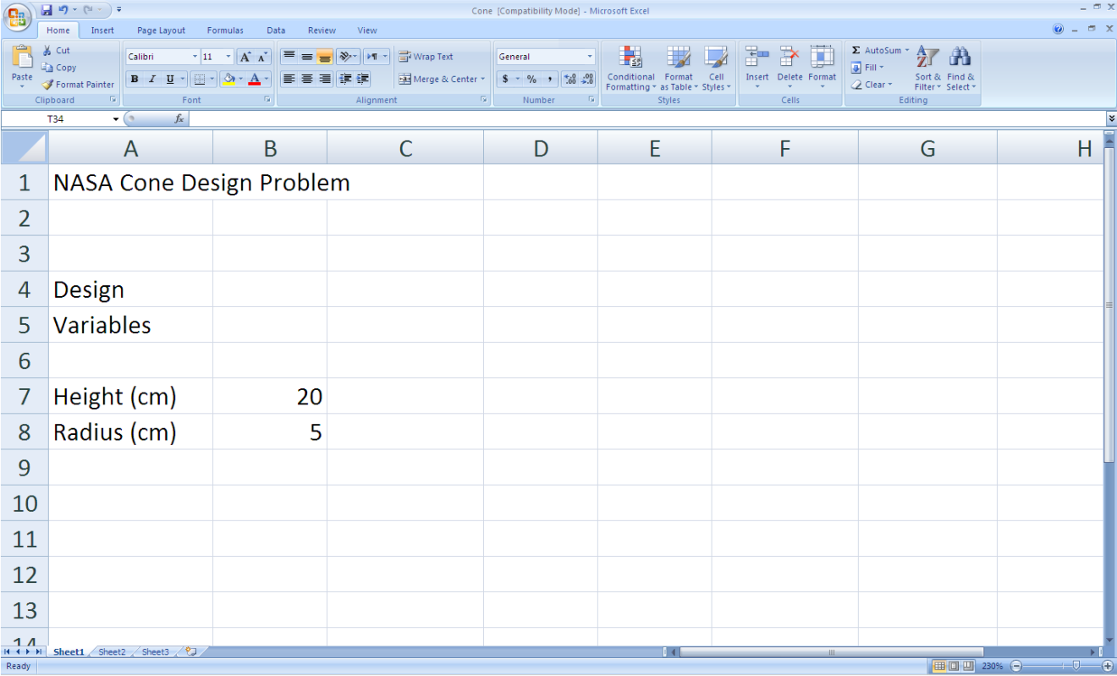

Now we will reserve the right-hand side for the author’s name and outputs (i.e. volume and area of the cone). The formulas should be entered as following:

“=(1/3)*pi()*B7*F7^2” for the volume.

“=pi()*F7*(B7^2+F7^2)^0.5” for the area.

For now, the spreadsheet looks like below:

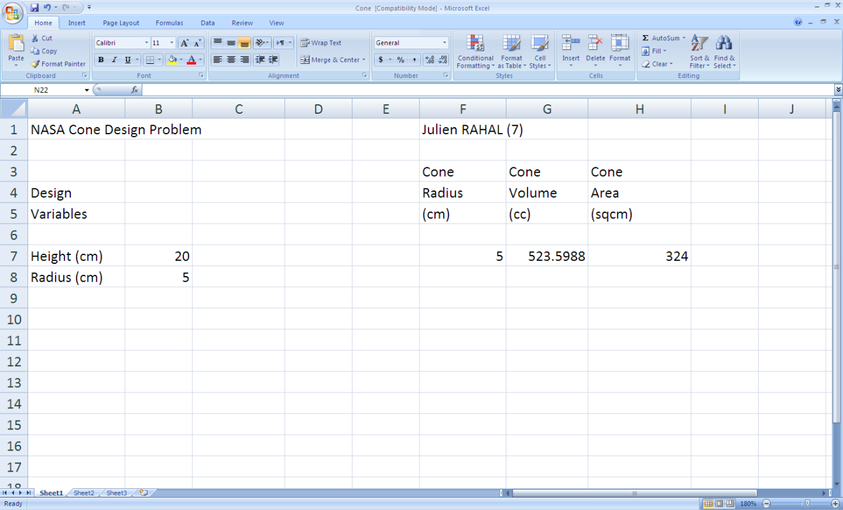

Changing the input variables leads to a viewable change in cells G7 and H7 representing the volume and area respectively.

Excel Tools:

The radius being variable, we don't have to enter each value every time. We can do it in a simpler way using relative and absolute addresses. Excel has an updating capability which will enter the appropriate formula into the cells below. This is the relative address feature of Excel. For example, if we expand the formula:

B1=A1+A2 to B2 and B3 using the “fill handle”, then B2=A2+A3, B3=A3+A4.

However, if we want to increment A2 only and keep A1 the same, we should change A1 into an absolute address by surrounding it by $ signs ($A1$).

The formulas to be entered are then:

=(1/3)*PI()*$B$7*F7^2 for the volume

=PI()*F7*($B$7^2+F7^2)^0.5 for the area

Then we expand the formula to the rest of the columns.

The spreadsheet should look like this after clicking on “show formulas”:

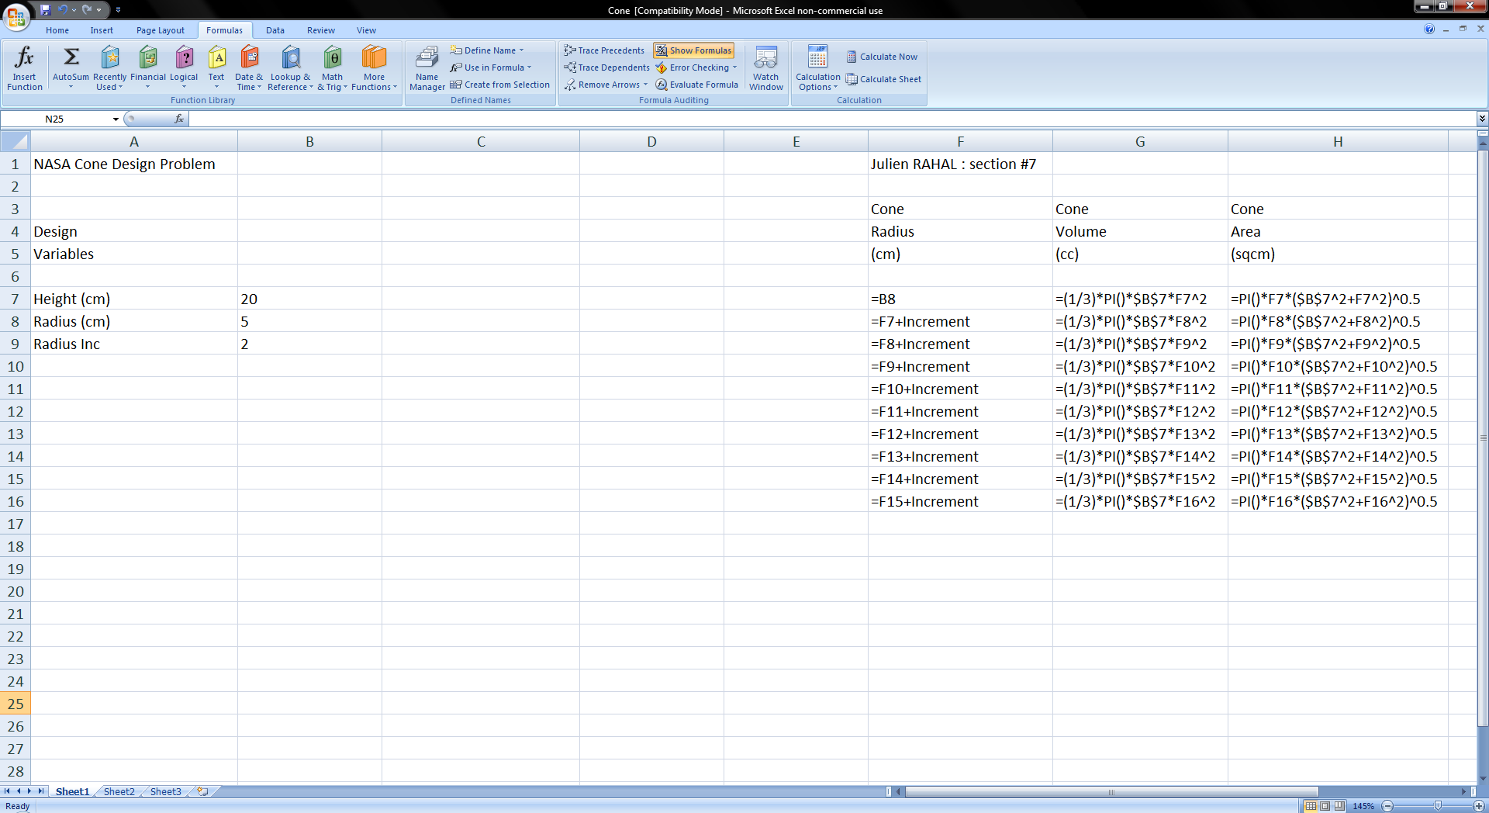

. **Creating a Chart:**

Another important tool in Excel is that of charts. We are interested in plotting the

volume and area as the function of the incremented radius.

To do this, insert “Scatter with smooth lines and Markers” chart from the “Scatter” tab in the “Insert” menu. Now click on “Select Data” button and choose the cells between F3 to H16 obtaining the following:

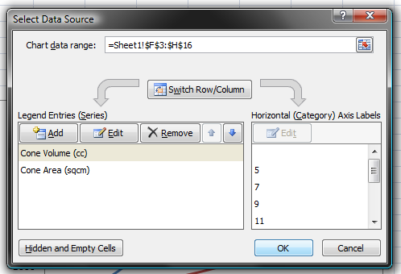

To label each axis, we click on “Axis Titles” in “Layout” menu of the chart tools. In addition, we might find other tools like “legend” and “chart title” useful for labeling purposes.

Results

After performing the above tasks the chart will look similar to what follows:

And the overall spreadsheet will looks as the following:

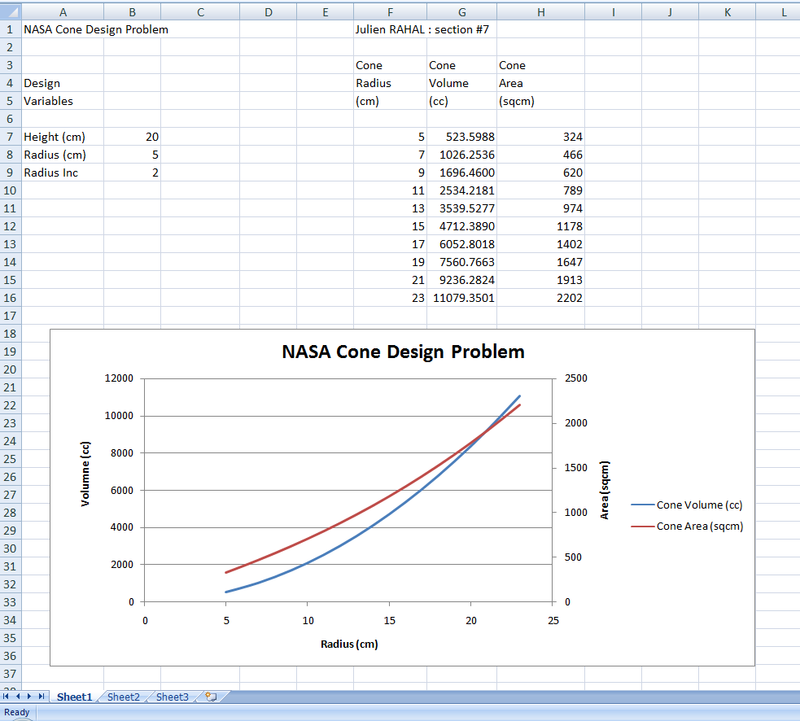

**Results Discussion:**

1. The chart reveals that the volume and surface area of a cone are exponential in growth.
2. It also shows the radius in which the volume is equal to the area (point of intersection of the 2 curves).
3. One more important result is the ability to approximate graphically the volume or

surface area at any radius, without using any additional calculations.

Conclusion

Excel gave us a simple way to notice how the volume and the area of a cone are related to its radius. Of course, this spreadsheet program can help us perform more complex tasks, making our lives easier.

References

“Cones”. <[www.mathworld.wolfram.com](http://www.mathworld.wolfram.com)>. Web.

“Introduction to Cone”. < www.emathzone.com>. Web.

Thomas, George. “Thomas Calculus”. Ed.Deirdre Lynch.12th ed.United States: Pearson.Print.

Appendices

**Appendix I: Excel Help**

To get more familiar with Microsoft Excel you can use “Microsoft Office Excel Help indicating all the basic features of Excel.

